To: Prof. Doherty
From: Charlotte Lawrence
Date: January 26, 2022
Re: Learnings from Demographic Disparities Analysis So Far

Changes to the Application of the Guidelines & USSC Reports

Since the United States Sentencing Guidelines were created in the late 80s, there have been a number of changes in the way they are applied to particular offenders’ cases. In Koon v. United States, 518 U.S. 81 (1996), the Supreme Court concluded that Congress intended appellate courts to afford “due deference” to lower courts’ decisions to grant a downward departure, instituting an abuse of discretion standard of review. In 2003, the PROTECT Act limited the downward departures available in certain child abuse and sex offense cases and also changed the appellate standard for sentencing decisions to de novo. On June 24, 2004, applying the Sixth Amendment to state law, the Supreme Court’s decision in Blakely v. Washington ruled that facts increasing the penalty for a crime beyond the prescribed statutory maximum must be submitted to a jury and proved beyond a reasonable doubt.
Applying Blakely to the federal realm, 2005’s United States v. Booker held that the existing guideline system violated the Constitution by permitting judges to find facts that raised the guideline range by a preponderance of the evidence, and that the beyond-a-reasonable-doubt standard should be applied instead. The opinion also invalidated provisions making the guidelines “mandatory,” rendering them “effectively advisory.”
A pair of 2007 cases affirmed the guidelines’ optional status. Gall v. United States upheld the trial court’s decision to depart below the guidelines because of an offender’s youth and rehabilitation, overruling the Eighth Circuit’s application of a “presumption of unreasonableness” to the sentence. Kimbrough v. United States made a similar ruling on analogous facts, upholding a trial court’s below-guideline sentence, indicating a willingness to accept some variability in sentencing but expressing confidence that district courts could still make reasonably uniform sentencing determinations.
The United States Sentencing Commission has issued a series of reports on the guidelines and their effects across the periods represented by these legal changes. Some of these reports seek to understand the effect of demographic group on sentencing outcome. In 2010, the Sentencing Commission authored an update to its earlier Booker Report which used a “refined model,” including several changes from the earlier Booker Report model. The refined model represents the Commission’s current best attempt to control for salient factors that influence sentencing. The coefficient on racial demographics, then, theoretically isolates the effect of demographic group, presumably acting through the bias of sentencing authorities (the probation officers preparing the PSR and/or the judge). Coefficients on other controls included in the model may also yield useful insights.

Interpreting Model Coefficients

Among the model’s most powerful explanatory variables – intuitively, in terms of statistical significance, and in terms of magnitude of effect – is the trumped guideline minimum (“logmin”). Other variables with consistently large effects across periods are the indicators for departures (upwards, downwards, and substantial assistance) and whether the individual was held in pretrial custody.
Importantly, though, direct comparison of the coefficient on the guideline minimum variable to the coefficients on the model’s indicator variables is not valid. Both the guideline minimum variable and the outcome variable (actual prison sentence imposed, in months) are log-transformed, meaning that log base e of each value is substituted for the actual value. The coefficient on a log-transformed explanatory variable where the outcome variable is also log-transformed is interpreted approximately in terms of percentage changes in both. So in this regression, a logmin coefficient of 0.68 indicates that for a 1% change in the trumped guideline minimum, the total prison sentence increased by approximately 0.68%.
A coefficient on an indicator variable requires a different transformation to enable interpretation. To interpret the coefficient on an indicator variable where the outcome is log-transformed: (eß – 1)*100 = percent change in the outcome attributable to the effect of the indicator variable, where ß is the coefficient. For instance, a coefficient of 1.07 on any of the indicator variables (say, the upwards departure indicator) means that offenders given any number of upwards departures receive 192% of the sentence received by those not given a departure. And a coefficient of -0.877 on the downwards departure indicator means that offenders given to a downwards departure receive a sentence 58% shorter than those not receiving a departure.
The model also controls for crime type, whether a departure was applied, whether the case went to trial, whether the defendant was held in pretrial custody, race, sex, age (above or below 25), education (whether the defendant ever attended any college), and citizenship. The below table provides the interpretation for the model’s coefficients over each of the periods covered. Coefficients not statistically significant at the 0.01 level are omitted (via recoding as 0). The rightmost column also gives a rough visual indication of how the magnitude of the effect changed over time via trend lines. Note that these trend lines are 1) representations of magnitude, not direction (so a change from -44% to -55% would be represented as an upward slope) and 2) not to scale, and so don’t speak to the relative magnitude of change over time in each variable’s coefficient. Time periods indicated on the above table are as follows: PROTECT Act (May 2003 to July 2004); Post-Booker (January 2005 to December 2007); Post-Gall (December 2007 to September 2011); Post-Report (October 2011 to September 2016); and Present (October 2016 to September 2021).

Coefficient Interpretations and Trend for the Refined Model Across Periods (2003-2016)

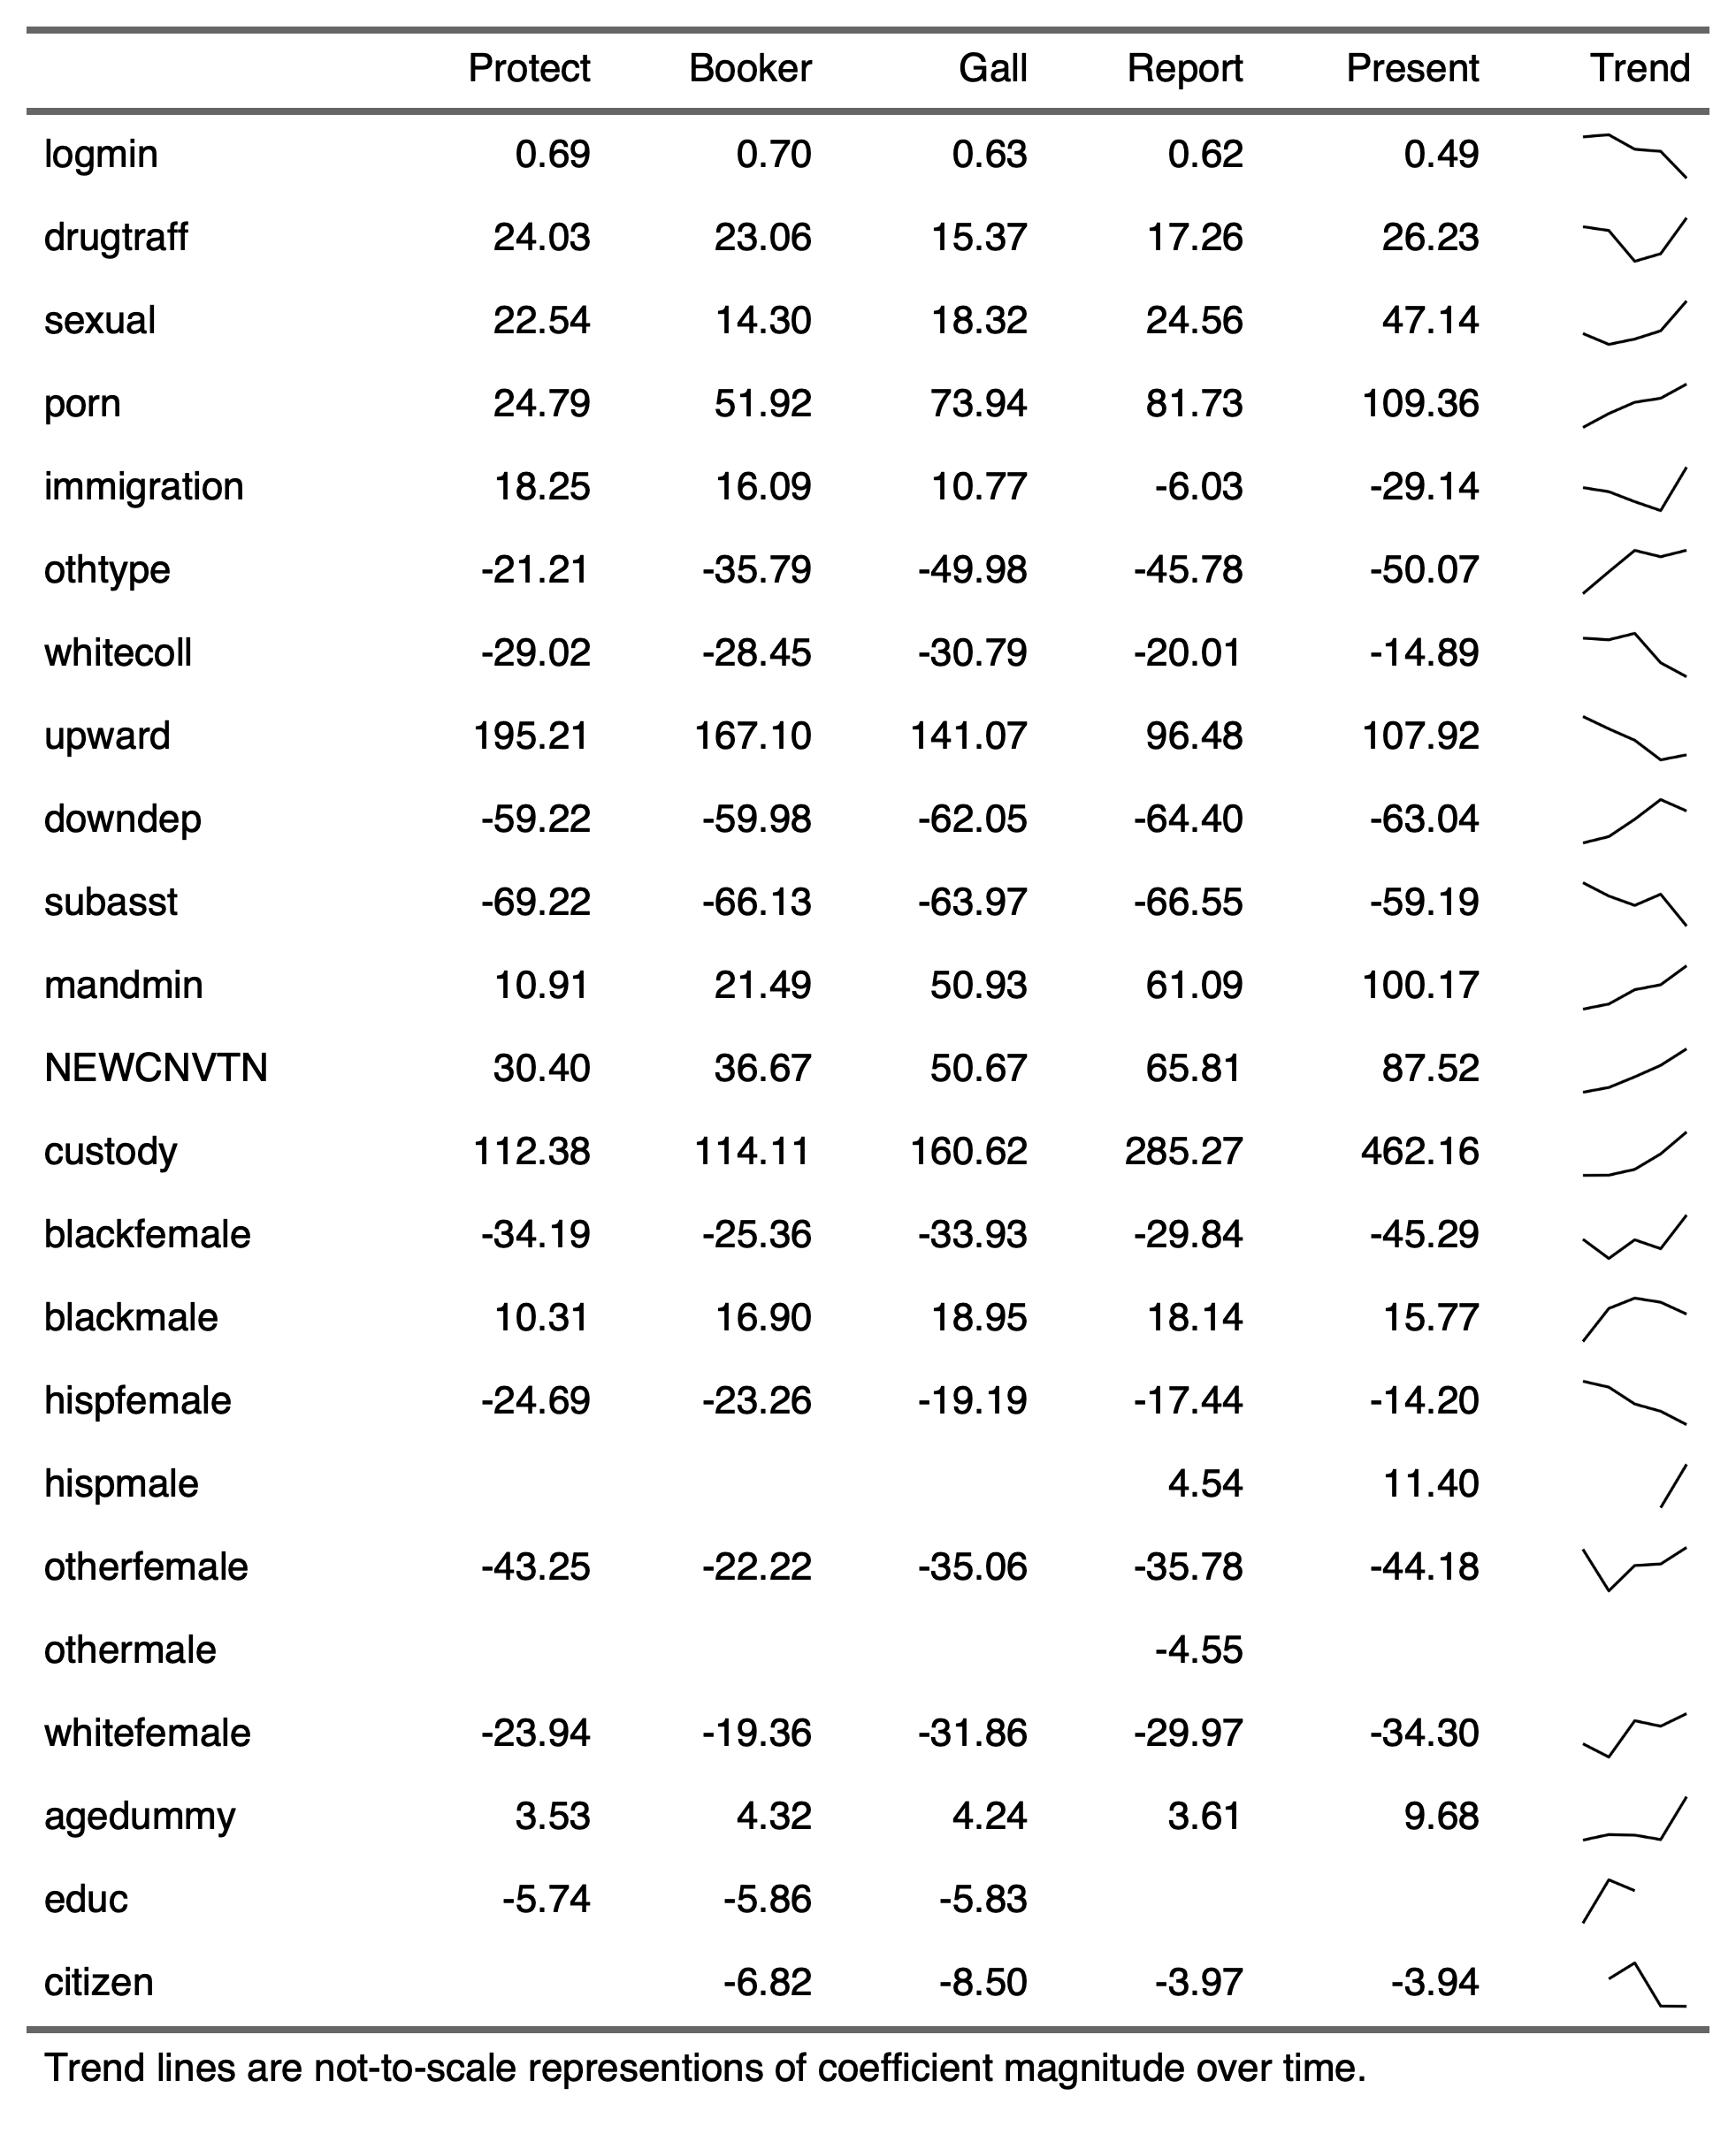

General Observations Regarding Refined Model Coefficients
This section makes a series of observations about data points and patterns, and then speculates about potential explanations. Someone with more familiarity with federal sentencing, changing attitudes towards crime, and changing crime patterns might have more thorough and accurate ideas about what factors driving various findings in the data.
Indicator variables for age, education, and citizenship display small effects on sentence length, mostly consistent over time. Being over the age of 25 consistently increased sentence length by a small percentage (though that percentage increase in the 2017-2021 period); attending college decreased sentence length by a slightly larger percentage on average; citizenship also decreased sentence length compared to non-citizens, though this effect was not statistically significant during PROTECT, when the guidelines were mandatory. One noteworthy observation is that citizenship, age, and education have smaller effects on sentence lengths than do the race and gender demographic group variables. This is most surprising with regards to citizenship, which might otherwise seem a likely source of bias.
The effect of some other variables changed in predictable ways as the guidelines became more discretionary. Going to trial increased sentence lengths, but the magnitude of the effect grew from PROTECT to the most recent period, perhaps because more rigid sentencing guidelines held plea deals closer to the available sentences that could be imposed at trial[?]. Being held in pretrial custody consistently doubled the sentence length imposed (a greater than 100% increase). This effect also increased greatly as the guidelines became more discretionary, reaching 160% during the Gall period, 285% during the post-Booker Report period (2012-2016), and 460% in the 2017-2021 period. Mandatory minimums also increased in importance over time—perhaps because the rigid effect of the guidelines functioned as de-facto minimums during the Protect period, decreasing the relative importance of actual statutory mandatory minimums[?]. The sharp upward trend in the size of the effect attributable to being held in custody, going to trial, and being sentenced to an offense carrying a mandatory minimum sentence may be worth further consideration. Why do these three factors display such a strong, uninterrupted upwards trend?
Below range sentences (downdep) and substantial assistance departures (subasst) had a relatively constant effect shrinking sentences across periods, but the effect attributable to sentencing a defendant above range (upward) became less important—had a smaller effect on sentencing—over time.
Trends in the effect of various crime types on sentencing over time were mixed. From 2003 to 2016, the effect of being sentenced for an immigration crime (relative to the violent crime baseline) switched from a relative increase in sentence to an ultimate decrease until fiscal year 2017 (beginning October of 2016), when it shot up again, perhaps corresponding to the beginning of the Trump Administration (and suggesting increased prosecution of lower-level immigration crimes[?]). Pornography crimes were sentenced more heavily than violent crimes, and that effect increased in magnitude as time went on. White collar crimes, sexual crimes, and drug trafficking crimes maintained relatively constant relationships to violent crime over the periods studied, though white collar crimes drew a bit closer and drug trafficking crimes diverged a bit in the 2017-2021 period. Trends in the effect of crime type on sentence length strike me as more likely to be related to changing social attitudes or societal crime patterns. [Unless there are reasons to expect that making the guidelines more or less mandatory would impact different crime types in different ways?]

Demographic Disparities + Baseline Switch
The model’s remaining variables are the indicators for demographic group, combining race and sex. When compared to the white male baseline, women display similar patterns across guideline application periods. The disparity between each group of women and white men decreases from the PROTECT period to the Booker period, then increases again from the Booker period to the Gall period—for non-Hispanic women. For Hispanic women, the disparity compared to white men shrinks steadily over all four periods studied. Understanding the move from PROTECT to Booker to Gall as a trend of increasing discretion, this might suggest that something other than raw discretion is driving the disparity between Hispanic women and white men (insofar as more discretion seems to actually be shrinking the disparity).
In the post-report period, the disparity between women and white men either stays about the same (“Other Female”) or decreases slightly again (all other groups). Of course, a shrinking disparity could be caused by an increase in women’s sentences, a decrease in white men’s sentences, or both (and the reverse is true of a growing disparity). Unfortunately, raw sentence lengths for each period do little to illuminate whether a smaller disparity reflects an increase in one group’s sentences or decrease in the other’s. This is because raw sentence lengths don’t account for the many other factors that may vary between periods (types of crimes committed, especially). Still, raw sentence lengths by demographic group and period are presented as the first figure in the Crime Type Breakdown document (“Average Sentence, by Demographic Group and Period”). The present period (2017-2021) increases the female/white male disparity for all racial groups except Hispanic women, who once again see the disparity vis-à-vis white men shrink.
The results for Black, Hispanic, and “other” men compared to white men illustrate the stark racial disparity between Black and white men—with Black men receiving 10 to 19% longer sentences, even controlling for the factors included in the model. It also illustrates the similarity between Hispanic, “other,” and white men’s sentences. Statistically significant differences are only evident in the post-report period, with Hispanic men receiving slightly higher sentences than white men, and “other” men receiving slightly lower sentences. The coefficients for Hispanic men and other men are consistently tiny across periods, although the fact that they become significant in the post-report and present periods could signify greater opportunity for bias to enter sentencing during those periods compared to earlier ones. On the other hand, though, post-report and present are the largest periods in terms of number of years and number of offenders sentenced, which makes them more likely to produce statistically significant results regardless.
Switching the baseline to white female (instead of white male) illuminates the following. Hispanic women receive about 18% longer sentences than white women, though that number jumps up to 31% in 2017-2021. “Other” females receive lower sentences—25% lower in the PROTECT period and 8% in the post-report period. Black women also receive lower sentences than white women. The missing bars represent periods for which findings were not statistically significant at the 0.01 level. Lack of statistical significance in the smaller periods isn’t particularly surprising given the overall lower number of women in the data. Using white women as the baseline, the graphs for disparities with men are largely the inverse of the female graphs using white men as a baseline and yield similar observations.
Using Hispanic women as the baseline throws into sharp relief the fact that Hispanic women receive far longer sentences than all other groups of women. This observation, as well as the fact that the pattern of change over time is slightly different for Hispanic women than for other women, warrants further consideration. [Could language barrier issues account for this difference? Something about the way that family circumstances are being applied, given some sort of differences in family structure?]
The Black female baseline is similarly illuminating: Black women receive lighter sentences, controlling for a variety of factors, than all other groups. A possible exception is other women, which are sentenced similarly enough to Black women that the difference is not statistically significant in any period. [Why do Hispanic and white women receive longer sentences than Black women? Something about family circumstances here too? Perceived aggression/transgression of white women in the system?]. Note here too that the disparity between Black women and Black men is much larger than the disparity between Black women and white men – 57 to 112%.
An interesting aspect of speculating about the underlying causes of demographic disparities in sentencing is that it necessarily invites stereotyping, particularly for an observer less familiar with the many realities of crime and the federal criminal legal system. Engaging in stereotyping might be a necessity, both because 1) some stereotypes speak to underlying patterns or realities and 2) stereotypes may function to influence the judge and probation officer who set the sentence. Still, some of my speculations presented here may be completely out of touch with reality or otherwise feed into harmful mindsets. At the least, acknowledging this dynamic should lead us to be especially mindful and rigorous in further investigation of the points raised.
Crime Type Tables
Provided in the document labeled “Crime Type Tables” are two sets of period-specific tables and one table that is aggregated across time periods but broken down by the specific guideline governing the crime.
The first table provided for each period lists the percent of all offenders in a given demographic group who were sentenced for that particular type of crime. Cells exceeding 40% are highlighted in red and cells indicating the between 20 and 40% of that demographic group was sentenced for a particular crime type are highlighted in orange. The second table provided for each period indicates the average sentence imposed for members of that demographic group being sentenced for that type of crime. Cells highlighted in red indicate an average sentence for that demographic group that is larger than the average sentence for that crime.
For both types of tables, patterns are relatively consistent over time. Black men received above average sentences for every crime type in every period, with the sole exception of immigration crimes during the post-protect period. Other groups consistently receiving above average sentences include Hispanic men, particularly for immigration, white collar, and “other” crimes. White men receive above average sentences particularly for immigration and sexual crimes, but only after Gall. In the Booker and Protect periods, white men only receive above average sentences for white collar crimes.
The distribution of crime types across demographic groups was even more consistent over time. For all groups, more than 20% of sentences concerned drug trafficking crimes. White collar popped up for white and other men and women (the other category including AAPI and native individuals).
The final table provided gives a breakdown of average sentence length by demographic group and specific sentencing guideline. The beginning of offense titles are provided for some crimes.

Family Ties Departures
A preliminary look at §5H1.6 family ties and responsibilities departures shows that a very small percentage of people being sentenced receive these departures (around 1.5% on average, with year to year variation). Very few of these departures are granted for pornography or sexual crimes; a larger portion are granted for drug trafficking, immigration, and white collar crimes. Women receive these departures at a far higher rate than men across racial groups. Hispanic females in particular tend to receive these departures at a higher rate than other groups for most crime types.
Incorporating family ties departures into the Commission’s refined model shows that a small part of the gender disparity between men and women is attributable to family ties departures. Adding family ties departures into the model as an indicator variable, the coefficient on female demographic groups shrinks slightly (as part of the effect being attributed to gender is shifted to family circumstances).

Aggravating and Mitigating Role Departures

A preliminary analysis of aggravating and mitigating role adjustments (departures through §3B1.1 and §3B1.2) reveals the following. Mitigating role adjustments are most common for drug trafficking crimes. Aggravating role adjustments are most commonly granted for sexual and white-collar crimes. Women receive mitigating role adjustments at higher rates than men and receive aggravating role adjustments at lower rates than men.

Next Steps

This memo is a work in progress. Next steps include 1) working with the Commission to refine the data analysis methodology and clarify questions around recording of variances; 2) extrapolating to more recent years’ data; and 3) conducting a review of existing literature on this data, sentencing disparities, and methodological or other criticisms of the Sentencing Commission’s analysis.

The PROTECT (Amber Alert) Act and the Sentencing Guidelines, Congressional Research Service (2005), https://www.everycrsreport.com/files/20050315_RL31917_df9195552d68000ebaceeaf6c645b69fa43baf56.pdf.
542 US 296 (2004).
543 US 220 (2005).
Id. Booker also instituted a three-step process to calculate sentences which considers the guidelines as well as any relevant policy statements, along with the other five statutory factors in 18 U.S.C. § 3553(a).
552 US 38 (2007).
552 US 85 (2007).
See Baseline Switch Reference Docs.
See Baseline Switch Reference Docs.
These indicator variables for above and below range sentences – upward and downdep – are not completely intuitive to interpret. Roughly speaking, the coefficient on upward roughly corresponds to the average increase in above-range sentences compared to within-range sentences, controlling for trumped guideline minimum, crime type, demographic group, and all of the model’s other controls. Treating above and below range sentences like this 1) assumes that above/below range departures and variances will have roughly similar effects and 2) assumes that the decision to grant a departure or variance is not itself linked to demographic group (or other covariates). Assuming one believes that the decision to grant a variances is related to race, for instance, then the coefficient on race might underestimate the true effect of race on sentencing.
Have the guidelines themselves changed over these periods? That could also explain some of the patterns in the data.
It may be worth speculating about why Booker would decrease disparities between women and white men but Gall would increase them again—something about Booker restricting upwards departures while Gall enabled greater downwards departures?
Statistical significance at the 0.01 level implies a less than 1% chance that the measured effect (embodied in the coefficient on the variable) is due to random chance rather than a true difference between groups. The generally accepted statistical significance level is 0.05 (corresponding to a 5% chance of error) but the Commission prefers the more rigorous 0.01 level.

